

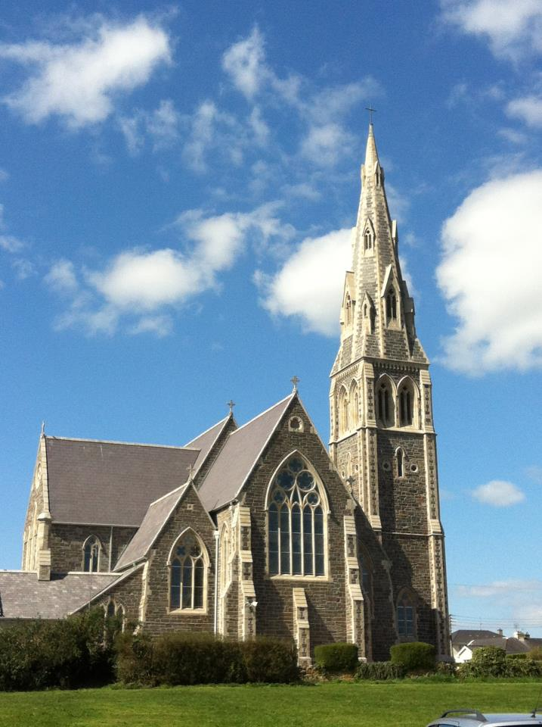

**Tramore & Carbally**

**Parish Newslink**

**Sunday 26th June 2016**

**13th Sunday in Ordinary Time**

11t

# Reflection for 13th Sunday in Ordinary Time

**The Lord We Serve**

Jesus said:***“Once the hand is laid on the plough, no one who looks back is fit for the kingdom of God”***. We live in a world in which people are finding it increasingly difficult to make a full commitment to anything. This is probably the single most important reason for many of the social ills of our society. Jesus tells us that commitment is essential to human fulfilment, the kingdom of God. When a couple gets married they are looking ahead but tend quickly to look back to what each had and so set limits to their relationship. When a couple conceive a child they look forward to the birth. Then they begin to look back to the freedom they had beforehand and try to reclaim as much of that as possible. And in parish life many people want a full part in the future of the Church but are often unwilling to commit themselves to the work involved in ensuring its success.

***Fr. Johnny Doherty, C.Ss.R.***

**Morning Prayer**

 Father in heaven, the light of Jesus

has scattered the darkness of hatred and sin.

Called to that light we ask for your guidance.

Form our lives in your truth, our hearts in your love.

We ask this through Christ our Lord.

**MASS TIMES**

*Holy Cross Tramore*

**Saturday**

10am

& 7.30pm (Vigil)

**Sunday**

8.30am, 10.30am and

12 noon

**Monday – Friday**

10.00am

**NO 7.30AM MASS FOR JULY & AUGUST**

***CONFESSIONS***

Saturday 10.30am & 7pm and upon Request

***NOVENA OUR LADY***

***OF PERPETUAL HELP***

Mondays after 10am Mass

***EXPOSITION OF THE BLESSEDSACRAMENT***

Thursday after 10am Mass until 5pm

*Our Lady’s Carbally*

**Sunday at 11.30am**

**OTHER LOCAL CHURCHES MASS TIMES**

*Church of the Immaculate Conception Fenor*

**Saturday Vigil at 6pm**

*Sacred Heart Dunhill*

**Sunday at 9.30am**

`

**Cemetery Masses**

The annual Cemetery Mass for all those interred in Tramore Cemeteries will take place on Thursday July 7th at 7.30pm.

The Annual Mass for those interred in Fenor Cemetery will take place on Tuesday July 5th and in Dunhill on Tuesday July 12th. All Masses at 7.30pm

Cafe Theology

***How to argue the Case of the Pro-Life Amendment***

Monday June 27th in the Granville Hotel (Tapestry Room)

There will be three speakers from Family & Life which is hosting the event:

Margaret Hickey, Sarah Ekada & Patrick Carr.

Plenty time for questions and discussions afterwards. All Welcome

For the Months of July & August there will be **NO 7.30AM** Mass in Holy Cross Church beginning on Monday 4th July.

**Please remember in your**

**Prayers……..**

**Those who have died recently:**

Paula Doyle nee Leahy

Terry O’Byrne

Gerry Clune

Mary Maher

**Those whose months mind occurs:**

Martin Flynn

Anne Galvin

Nena Monsanto

**Those whose anniversary occurs:**

Martha Power

Breda & Christopher Delaney

Ray Barlow

**-----------------------------------------Those who were baptised recently:**

Tom O’Rourke-O’Mahony &

Mia Joy O’Neill

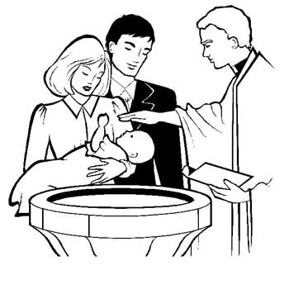

**Congratulations to their parents and godparents**

**------------------------------------------**

**For those who were married recently:**

Patrick Tobin & Aoife Gavin

Denis Kent & Lorna Power



**We wish then every blessing in their married life together.**

**------------------------------------------Collections Last Weekend:**

**Tramore €** **5380**

**Carbally € 215**

**Special Family Collection**

**€1805**

Thank you for your continued support for the upkeep of our Churches

-----------------------------------------------

**The Mass Book for December 2016 opens at the Parish Office on Friday July 1st.**

Tramore & Carbally Parish Newslink

|  |  |  |
| --- | --- | --- |
| Saturday 25th June | ***10.00am*** | Sean, John & Helen Cantwell |
|  | ***7.30pm*** | Pa Corcoran |
|  |  |  |
| Sunday 26th June | ***8.30am*** | Tony, Dick & Renee Power |
|  | ***10.30am*** | Donal O’Brien |
|  | ***12.00 noon*** | Francis McLysaght |
|  |  |  |
| Monday 27th June | ***7.30am*** | Elizabeth Murphy (Months Mind) |
|  | ***10.00am*** | Jim Brophy |
|  |  |  |
| Tuesday 28th June | ***7.30am*** | Maura Arnold |
|  | ***10.00am*** | Kathleen Kelly |
|  |  |  |
| Weds 29th June | ***7.30am*** |  |
|  | ***10.00am*** | Desmond Quinlan |
|  |  |  |
| Thursday 30th June | ***7.30am*** | Tom Grace |
|  | ***10.00am*** | Annie & Patrick Dunphy |
|  |  |  |
| Friday 1st July | ***7.30am*** | **HOLY SOULS** |
|  | ***10.00am*** | Risteárd & Bríd Ó Murchú , John & Frances Kearns |
|  |  |  |
| Saturday 2nd July | ***10.00am*** | Margaret Fleming |
|  | ***7.30pm*** | Evelyn & Francis Power |
|  |  |  |
| Sunday 3rd July | ***8.30am*** | Maher Family & Torpey Family (Queen Street ) |
|  | ***10.30am*** | Tony o’ Neill |
|  | ***12.00noon*** | James Travers |
| **CARBALLY**  Sunday 26th June | ***11.30am*** | William Bolger ,Chrissie Murphy, Tom & Mary Murphy,(Ballygarron ),Bill Smith (Dunmore East), Cathy Keane  **Sea Horse Commemoration 1816-2016**  1-3 July 2016  ***All welcome to join us to unveil the Commemoration Cairn and honour our Costal Rescue Services***.  Friday 1 July ***Welcome Dependents*** 7pm Launch on the Promenade*.*  Sat 2 July ***Unveiling the Cairn***  12pm Lower Promenade.  9.30pm ***Lighting–up the Metal Man***  Sun 3 July ***Ceremony and Walk*** on the Doneraile to Coastguard station at 12pmTom and May Murphy, Balkygarron  Cathy Keane  Bill Smith , Dunmore East  You are invited to the next session of Cafe Theology on  **How to Argue the Case for the Pro-Life Amendment.**  **Monday June 27th at 7.30pm in**  **The Granville Hotel (Tapestry Room)**  There will be three speakers from Family & Life which is hosting the event:  Margaret Hickey, Sarah Ekada and Patrick Carr.  Plenty of time for questions and discussion afterwards.All welcome |

**Meals on Wheels- Volunteers Required**

Due to retirements and holidays volunteers are **URGENTLY REQUIRED** to help with the service. Over 50 meals a day are prepared and delivered to members of community.

Volunteers help prepare the meals, deliver them, wash up duties etc.

Please contact 051-381126 before 11.30am

**All events start at 8.00 pm.**

**OLD PHOTOGRAPHS**

We are planning some events to celebrate the 150th anniversary of our school: Star of the Sea School (1866) and Edmund Rice School (1867).We would be grateful for any photographs (NOT originals) or materials you may have which relate to the schools. Perhaps, members of your family, neighbours/grandparents may have some also.

If so, please hand them into the school, any day before 28th June. We would appreciate if you would date the photos and include any names, where possible. Contact person: Sr. Catherine Thank you for your support.

Volunteer urgently required for the Sue Ryder Foundation Charity Shop on Main St Tramore.

Application forms available in store.

Volunteer Urgently Needed for The Sue Ryder Foundation Charity Shop Tramore  
Applications Available in store

A Gents Wristwatch found on the Church grounds

Contact: 087-2143366

Tramore Tidy Towns  
If you have a spare hour and would like to help, Tramore Tidy Towns will meet every Tuesday and Thursday evening during the summer months at 7pm at the car park opposite the SuperValu entrance.  
If you would like to get involved in anyway with Tramore Tidy Towns - be it a suggestion you have for a project or would like to become a committee member, we always welcome new ideas and especially new help.

Please contact Anne Cheasty c/o SuperValu [051 386036](tel:051%20386036).

Tramore Tidy TownsTramore Tidy Towns  
If you have a spare hour and would like to help, Tramore Tidy Towns will meet every Tuesday and Thursday evening during the summer months at 7pm at the car park opposite the SuperValu entrance.  
If you would like to get involved in anyway with Tramore Tidy Towns - be it a suggestion you have for a project or would like to become a committee member, we always welcome new ideas and especially new help.

Please contact Anne Cheasty c/o SuperValu [051 386036](tel:051%20386036).

If you have an hour to spare, and would like to help. Tramore Tidy Towns will meet every Tuesday & Thursday evenings in the car park opposite Supervalu entrance at 7pm.

If you would like to get involved in any way with Tramore Tidy Towns-be it a suggestion a project or you would like to become a committee member, we always welcome new ideas and especially new help.

Please contact Ann Cheasty 051-386036Tramore Tidy Towns  
If you have a spare hour and would like to help, Tramore Tidy Towns will meet every Tuesday and Thursday evening during the summer months at 7pm at the car park opposite the SuperValu entrance.  
If you would like to get involved in anyway with Tramore Tidy Towns - be it a suggestion you have for a project or would like to become a committee member, we always welcome new ideas and especially new help.Please contact Anne Cheasty c/o SuperValu [051 386036](tel:051%20386036).Tramore Tidy Towns  
If you have a spare hour and would like to help, Tramore Tidy Towns will meet every Tuesday and Thursday evening during the summer months at 7pm at the car park opposite the SuperValu entrance.  
If you would like to get involved in anyway with Tramore Tidy Towns - be it a suggestion you have for a project or would like to become a committee member, we always welcome new ideas and especially new help.Please contact Anne Cheasty c/o SuperValu [051 386036](tel:051%20386036).Tramore Tidy Towns  
If you have a spare hour and would like to help, Tramore Tidy Towns will meet every Tuesday and Thursday evening during the summer months at 7pm at the car park opposite the SuperValu entrance.  
If you would like to get involved in anyway with Tramore Tidy Towns - be it a suggestion you have for a project or would like to become a committee member, we always welcome new ideas and especially new help.Please contact Anne Cheasty c/o SuperValu [051 386036](tel:051%20386036).

**Next Week's Teams: 2/3 July**

**Readers:** Team **B**

**Ministers:** Team **1**

**Cleaners:** Marie Kennealy& her team

**Altar Servers** St Patrick