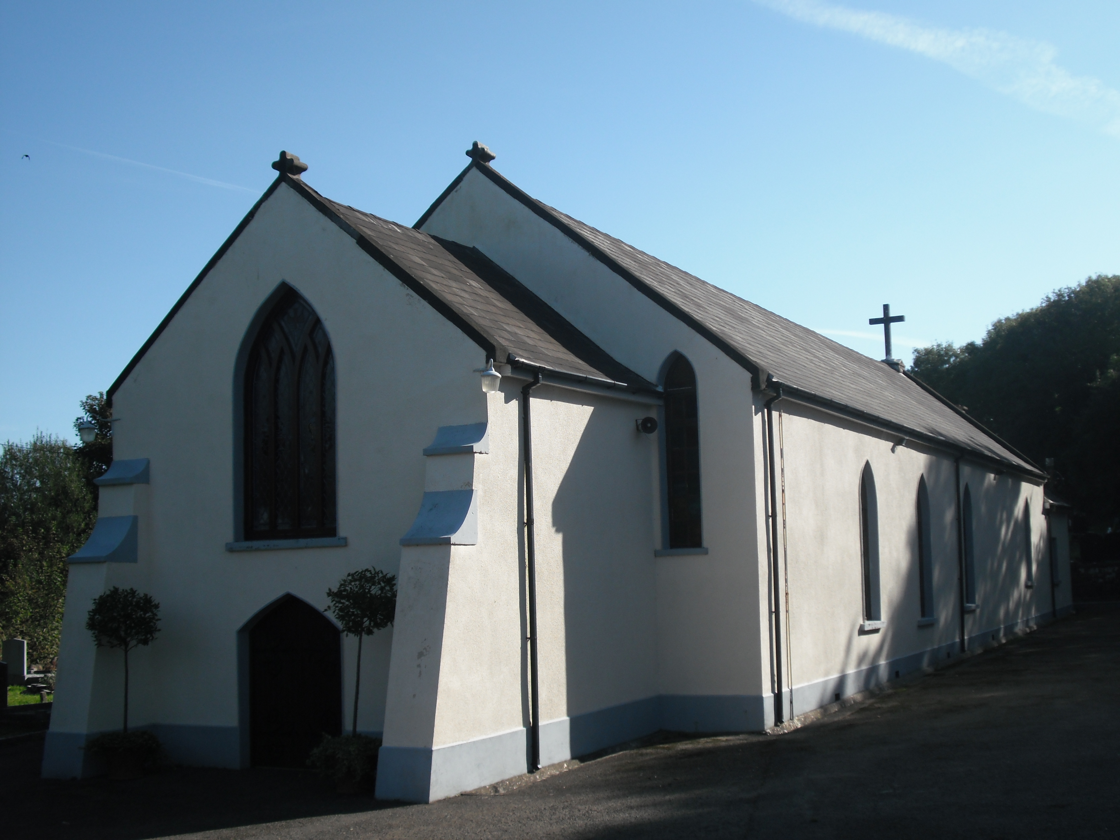
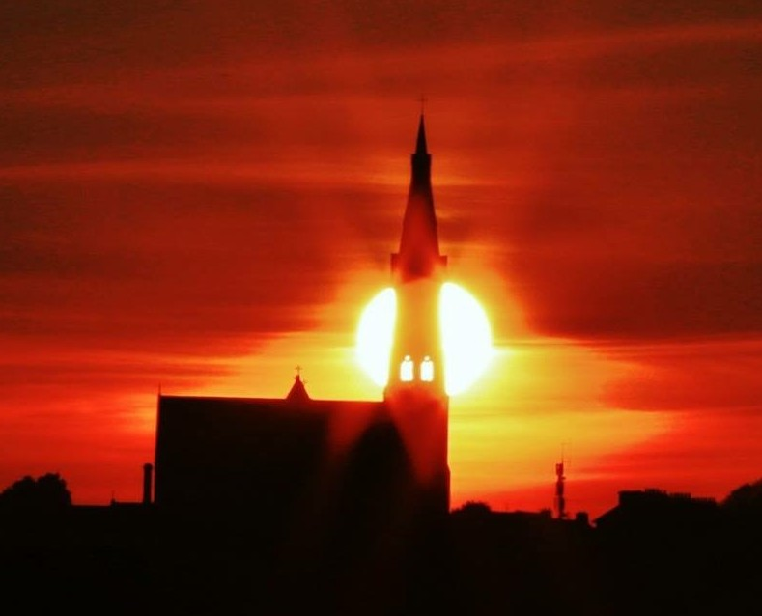

Tramore & Carbally

Parish Newslink

Sunday April 12th 2015

2nd Sunday of Easter/ Divine Mercy

ASH WEDNESDAY MASSES
.
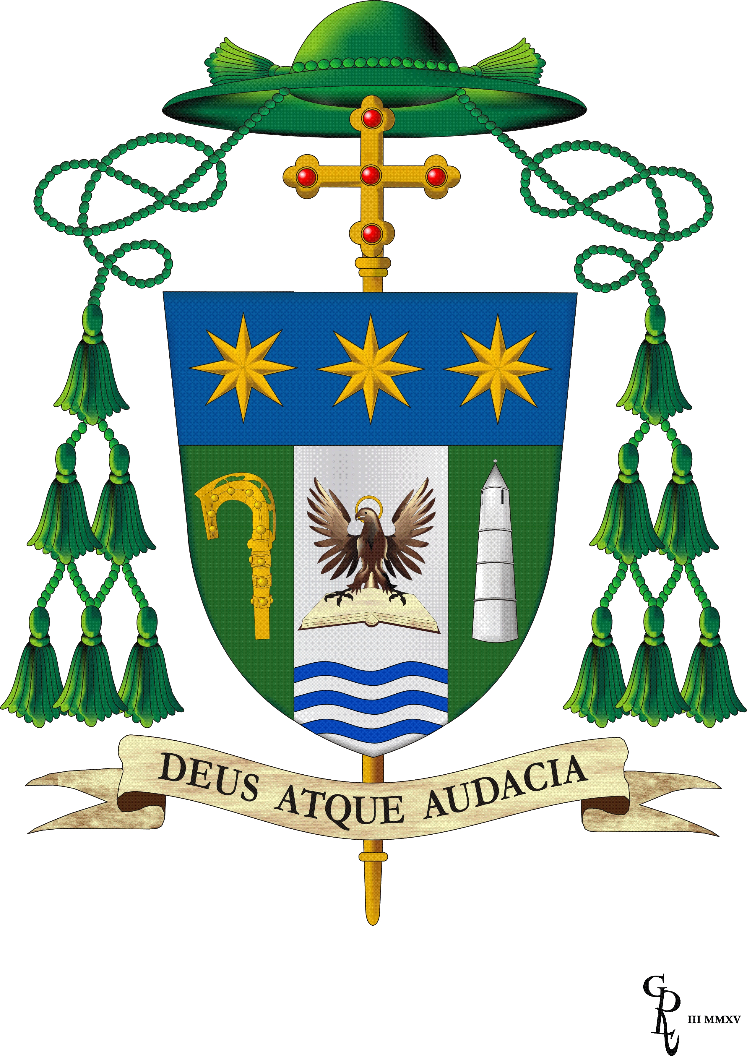

EPISCOPAL ORDINATION OF ALPHONSUS CULLINAN
The ordination of our new Bishop takes place this weekend in the Cathedral of the Most Holy Trinity, Waterford. This is a great day for our diocese, and our prayers and support are asked for Alphonsus as he is ordained and appointed to the diocese of Waterford and Lismore. Due to space restraints, this is a ticket only ceremony. However, the ceremony will be broadcast live on WLRFM from 3pm.

Each parish was invited to ask our young parishioners to compose a ‘Prayer for the Future’ which will be printed on a piece of brick, and placed into the round tower model of St Declan’s tower as part of the ordination ceremony. Class 2G of Ardscoil na Mara have composed the prayer on behalf of all our young parishioners, and Clara Crehan, from the pope John Paul II Award, will represent the parish as she places this prayer into the round tower.

We pray for Alphonsus, and look forward to welcoming him next Thursday for the Confirmation in Dunhill Church.

‘Prayer for the Future’ from 2G - Ardscoil na Mara

Dear Lord, watch over Bishop Alphonsus as he embarks on his new role. May you empower him as he leads the Community of Waterford and Lismore on their faith journey.
May God’s Holy Spirit be present in the life of young people and ensure that their hopes and dreams are fulfilled in the future.
Please Father help us and the Church by giving us strength for all that we may encounter along the road of life. Ní neart go cur le chéile.
Thank you God for what was, what is and what will be.
Amen.
MASS TIMES
Holy Cross Tramore
Saturday
10am
& 7.30pm (Vigil)
Sunday
8.30am, 10.30am and
12 noon
Monday – Friday
7.30am &10am

CONFESSIONS
Saturday 10.30am & 7pm and upon Request

NOVENA OUR LADY
OF PERPETUAL HELP
Mondays after 10am Mass

EXPOSITION OF THE BLESSED SACRAMENT

Thursday after 10am Mass until 5pm

CHURCH CLOSES AT 5PM, SUNDAY TO FRIDAY INCL

Our Lady’s Carbally
Sunday at 11.30am

OTHER LOCAL CHURCHES MASS TIMES

Church of the Immaculate Conception Fenor
Saturday Vigil at 6pm

Sacred Heart Dunhill
Sunday at 9.30am

Please remember in your prayers……..

Those who have died recently:

Those whose Months mind occurs:
Pauline Kiely
Noel O’Reilly
Ted Heazle
William McGrath

Those whose anniversary occurs:
Tadgh O’Donoghue
Lily Martin
Esther Griffin
John Harte Lodge
Jim Power
John Rogers Te Terrace
______________________________
Collections Last Weekend:
The collection last weekend was for the support of the Priests of Our Parish.
Thank you most sincerely for your continued generosity.

---------------------------------------------------------

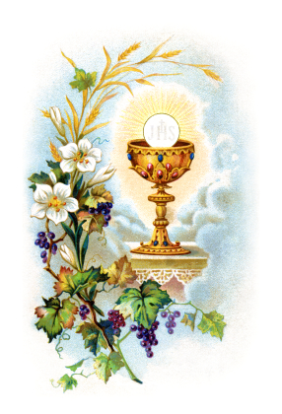

At the parish Office

Lovely selection of Prayer Books, Rosaries, Cards and gifts for First Holy Communion are now available

Please feel free to drop in
and have a look .

Tramore & Carbally Parish Newslink
Saturday 11th April | 10.00am | Mary & William Power
 | 7.30pm | Bill & Billy McDonnell
Sunday 12th April | 8.30am | Tommie Browne
 | 10.30am | Tadgh O’Donoghue
 | 12 noon | Billy & Peggy Butler & Family
Monday 13th April | 7.30am | Patrick Cowman
 | 10.00am | Tom McCarthy & Gertrude McCarthy
Tuesday 14th April | 7.30am | Sandra O’Sullivan
 | 10.00am | Pádraigh Cuddihy
Weds 15th April | 7.30am | Noel O‘Reilly (Months mind)
 | 10.00am | Joan McCarthy nee Cowman
Thursday 16th April | 7.30am | Paddy McSweeney, John & Mary French
 | 10.00am | Joyce Robinson
Friday 17th April | 7.30am | HOLY SOULS
 | 10.00 am | Valerie & Tom Hennessy
Saturday 18th April | 10.00am | John Dunphy & daughter Bríd
 | 7.30pm | Anna Murray &sons Benny & Jim
Sunday 19th April | 8.30am | Tom & Mary Skehan
 | 10.30am | Ellen Murphy
 | 12.00noon | Mar
CARBALLY  Sunday 12th April | 11.30am | Shane Fitzgerald, John Cosgrave Bellelake
Sunday 19th April  Secular Franciscan Order  Monthly Meeting at 7pm Wednesday15th April Sisters of Charity Convent.  All welcome | 11.30am | Come Gather Celebrate  Next weekend, we welcome the children who are making their Holy Communion this year and their parents to our parish preparation programme  We welcome the pupils from GLÓR NA MARA and GAELSCOIL PHILIB BARÚN and their parents to 7.30pm Mass on Saturday 18 April.  And pupils from HOLY CROSS SCHOOL and their parents at the 12 noon Mass on Sunday 19 April  Please remember them in your prayers at this important time in their lives

El

Tramore ICA

Next meeting our AGM
Tramore House on Wednesday 8 April at 8pm.

Please don’t forget that your yearly membership subs are due this month.

Important reminder of our 70thAnniversary dinner at the Majestic Hotel on Friday 10 April at 7.30 sharp.

Tickets will be on sale at our Guild meeting.
Another date for your diary is the Federation meeting on Monday 20 April at Crottys. Hope you attend.

Mass

.
“THANK YOU”
€2,800 was raised at our recent concert. Sincere thanks to our choirs, musicians and to those who attended the event which was a fabulous evening. The funbds are going towards the window restoration.
Next Week's Teams: 18/19 April

Readers: Team B
Ministers: Team 2
Altar Servers: St Patrick
Cleaners: Marie Kennealy and her team
The next Coffee Morning in aid of the Tramore Hospice Support Group will be hosted by The Sands Hotel Tramore on Thursday 16th April at 11.00am.
This is a great location and of course there will be the usual teas and coffees and some yummy goodies to relish mid morning. A raffle will of course be held for all kinds of interesting prizes.
Please come along and support this very worthy cause.

