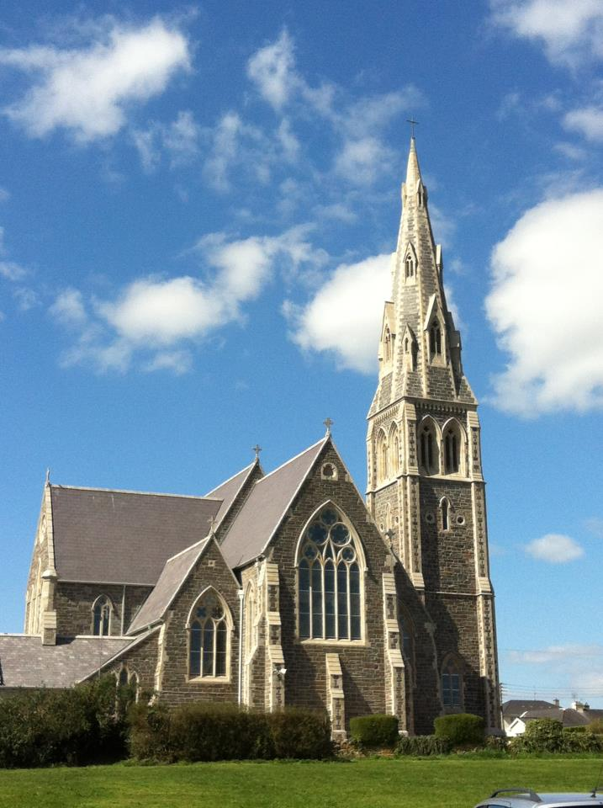

Tramore & Carbally

Parish Newslink
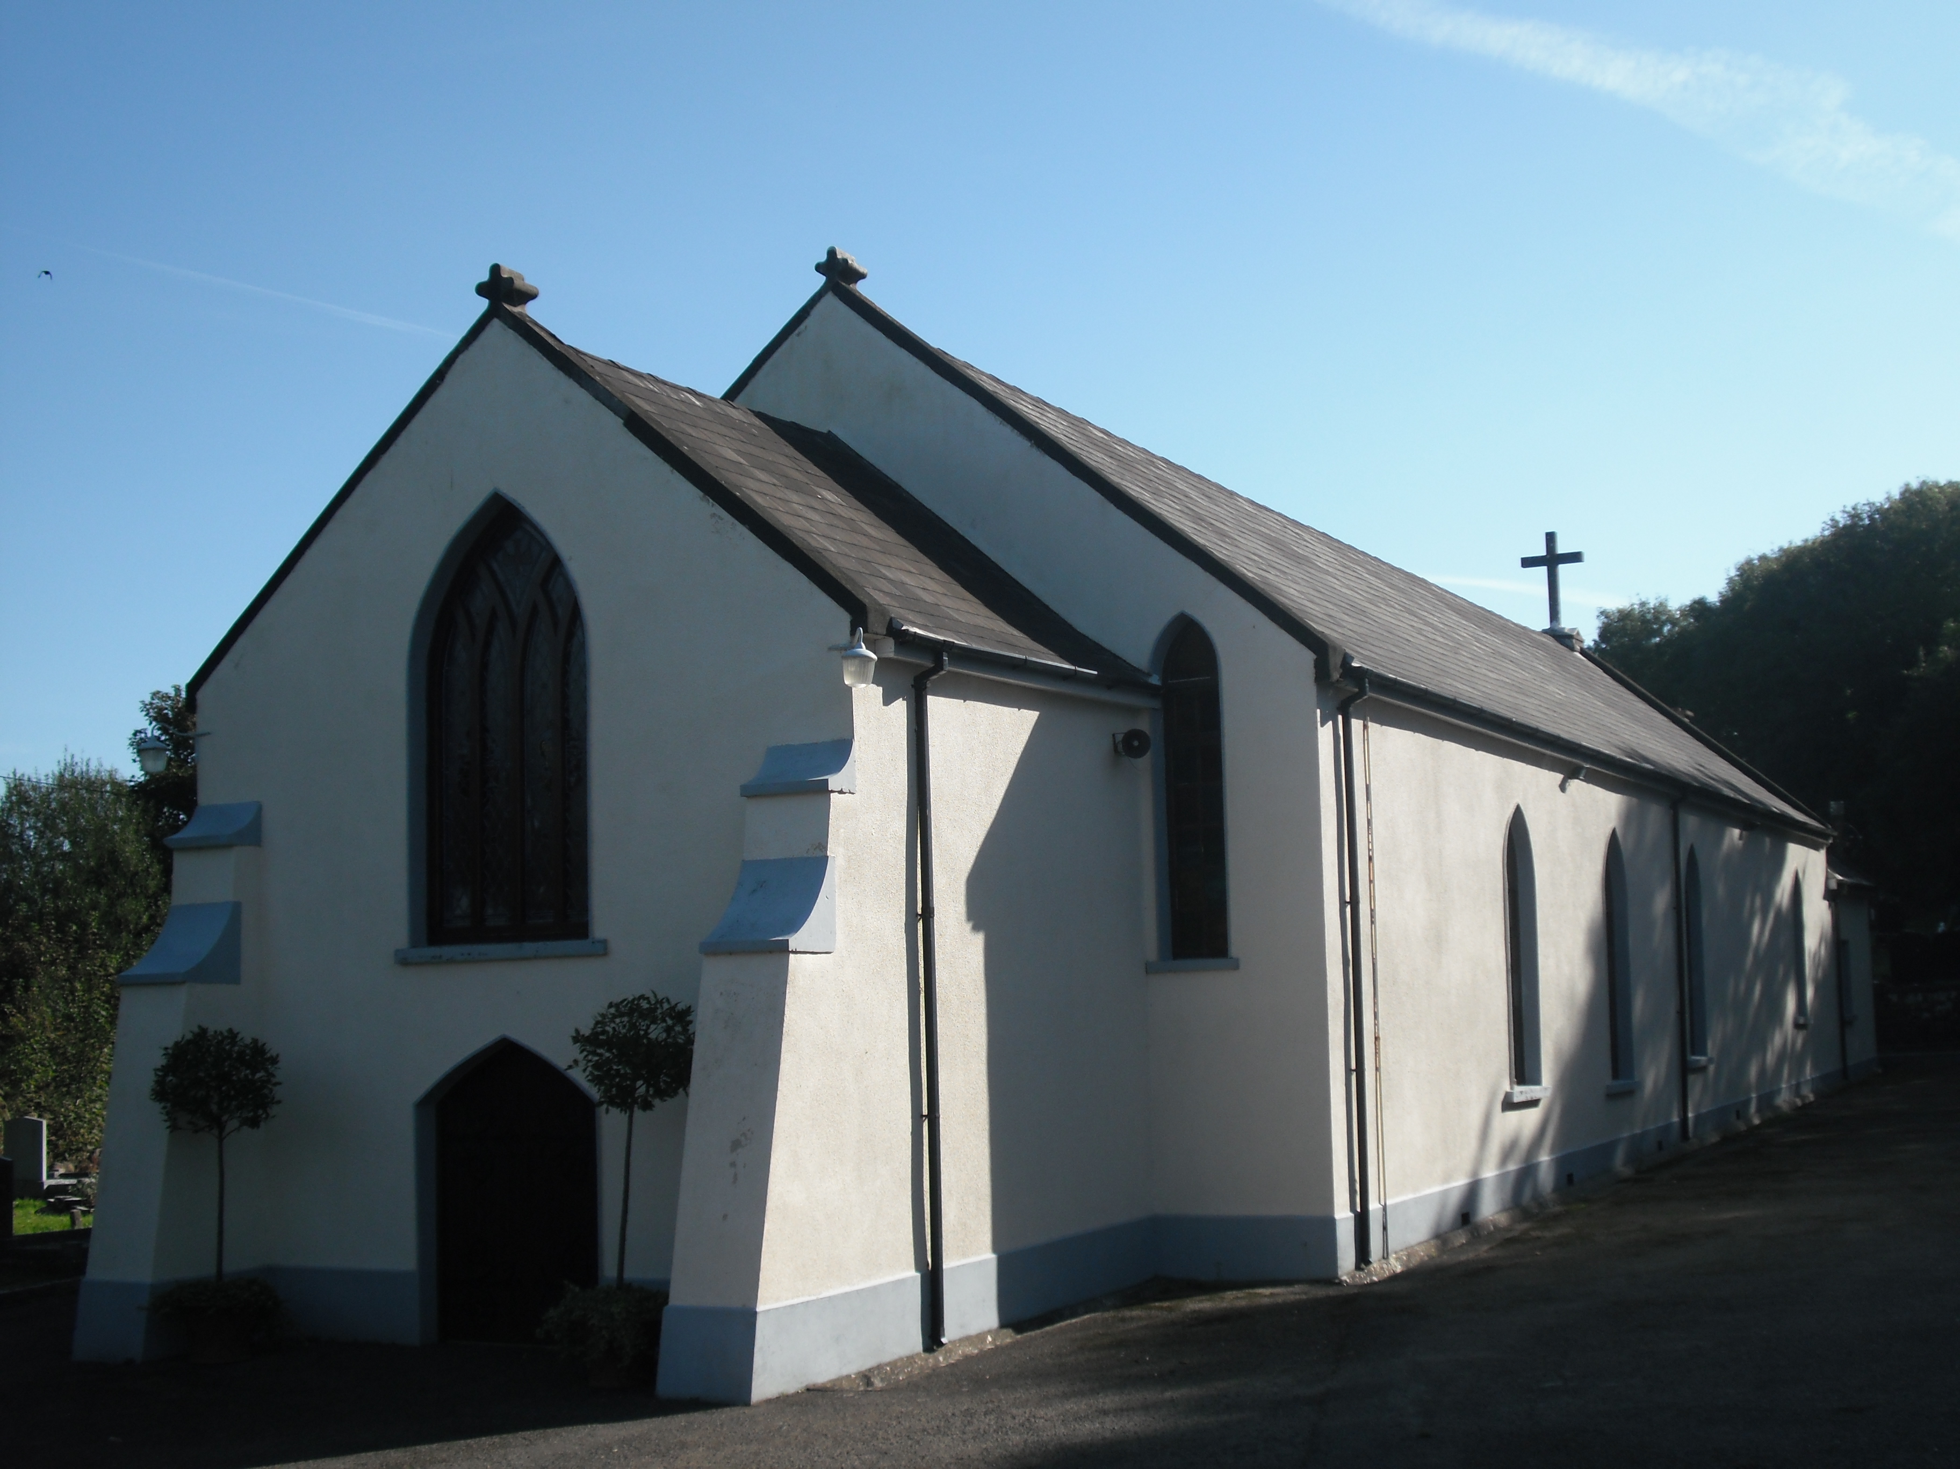

Sunday 26th July 2015

17th Sunday in Ordinary Time
11

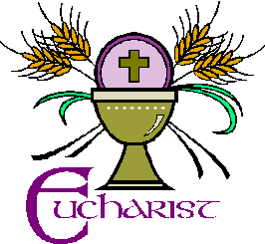
EUCHARIST - BE TRANSFORMED!
An Irish writer in medieval times described the Eucharist as ‘a dangerous prayer’ because it expresses a readiness to let God transform us in whatever way he chooses. For the next five Sundays the gospel of John invites us to reflect on what it means to pray Eucharist, to be Eucharist, to do Eucharist, to live Eucharist. To understand the amazing gift that the Eucharist is we need to understand the giver. In the Eucharist Jesus offers us the fruits of his life, his death and his resurrection. He gives us what he calls living bread come down from heaven. Through this gift he wants us to become fully alive. This coming alive can happen in many ways.

Jesus grew up in a religious tradition which regarded food as sacred. Bread was to be treated with respect and never to be thrown away. The Law directed that thanks be given after every meal. The word Eucharist means thanksgiving. To give thanks is to be alive and alert to God’s goodness.

The bread and wine don’t resist the transforming presence of the Holy Spirit. We can resist. Sin is resistance to God, it limits our ability to love. The gospel passage today links the miracle of the loaves with the feast of Passover. Passover celebrated with great joy how God had freed his chosen people from slavery in Egypt and how he continued to lead them to freedom. Jesus brings a new Passover, a liberation from all that restricts our freedom. The only authentic freedom is the freedom to love, to love as he loves. In the Eucharist we remember and celebrate his commitment to bring about that freedom.

Today’s gospel offers some examples of that freedom. A large crowd gathered to hear Jesus. He satisfied their hunger for bread, but not their hunger for power. The abundance of bread and fish gave rise to joy and gratitude. Efforts to control Jesus and exploit his popularity for political ends failed. Jesus claimed his freedom, he refused to let himself be used by others for their purposes. The boy with the five barley loaves and the two fish is a model of generosity. He has the freedom to share the little he has and see how in Jesus’ hands it is multiplied. There are times when we share the little we have and then discover how much we have left over. At every Eucharist we express our faith, our praise of God, our availability for transformation, and pray for growing inner freedom.

MASS TIMES

Holy Cross Tramore
Saturday
10am
& 7.30pm (Vigil)
Sunday
8.30am, 10.30am and
12 noon
Monday – Friday
10am

CONFESSIONS
Saturday 10.30am & 7pm and upon Request

NOVENA OUR LADY
OF PERPETUAL HELP
Mondays after 10am Mass

EXPOSITION OF THE BLESSED SACRAMENT

Thursday after 10am Mass until 5pm

Our Lady’s Carbally
Sunday at 11.30am

OTHER LOCAL CHURCHES MASS TIMES

Church of the Immaculate Conception Fenor
Saturday Vigil at 6pm

Sacred Heart Dunhill
Sunday at 9.30am

THANK YOU

Fr Shane O’Neill would like to thank most sincerely all those who attended the Mass of thanksgiving on Thursday, and to all who participated in the liturgy and those who made refreshments afterwards.

The huge crowd who waited for up to two hours for the first blessing was a testament to the wonderful occasion of a newly priest ordained in our diocese. We all wish Fr. Shane ad multos annos!

Please remember in your

prayers……..

Those who have died recently:

Connie Whittle

Gerry Rush

Michael Griffin

Michael Stone

Anne Brennan Nee Mills (Died in England)

Those whose months mind occurs:
Mary Molloy (Priests Road)

Those whose anniversary occurs:
Toddy Fennell
Joan Coady
Mary Mackey
Peter & Alice McNally
Sean Power, Michael & Mamie & Hannah
Noel Griffin
-------------------------------------------For those who were married recently

Colin Brady & Shannon Alburger

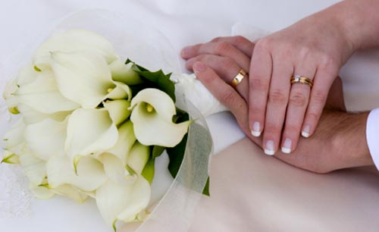

We wish them every happiness for their married life together.
––––––––––––––––––––––––––––
Collections Last Weekend:

Tramore € 4135
Carbally € 275
Thank you for your continued support for the upkeep of our churches.

We ask people to refrain from going onto the sanctuary area in Holy Cross church. In recent weeks candlesticks have been knocked over and the loud speaker system has been interfered with. Special care should be exercised when small children accompany you to church.

Tramore & Carbally Parish Newslink
Saturday 25th July | 10.00am | Michael, Bridget, Declan & Anne Cullen
 | 7.30pm | Kevin Doyle
Sunday 26th July | 8.30am | Alison & Edmond Hartley & Ita Roberts
 | 10.30am | Michael Power (Peter’s Place)
 | 12 noon | Michael Hewison, Sr Agnes Culliton & Gerry Culliton
Monday 27th July | 10.00am | Tom Grace 1st Anniversary
Tuesday 28th July | 10.00am | Sean Power Michael, Mamie & Hannah Power
Weds 29th July | 10.00am | James Barrett
Thursday 30th July | 10.00am | Michael Dunphy
Friday 31st July | 10.00 am | HOLY SOULS
Saturday 1st Aug | 10.00am | Mick & Peggy O’Sullivan
 | 7.30pm | Peggy Flavin
Sunday 2nd Aug | 8.30am | Joseph Brophy (Jo Jo) and baby sister Esther
 | 10.30am | Mary Walsh, Walsh & Kavanagh Families
 | 12.00noon | Kathleen & William Jordan
CARBALLY  Sunday 26th July | 11.30am | Helen Kearney ( Months Mind ) Dan Daly, Joan Power , Woodstown, John Cathy & Alice Phelan Kilmaquague
Sunday 2nd Aug | 11.30am | Dolly & Richie Phelan

Launch of Laudato Si, Care for our Common Home.
On Tuesday 28th July, 7.30pm.in the Tower Hotel, Fr. Sean McDonagh, a leading environmental theologian who was involved in the drafting of Laudato Si, will introduce the Encyclical to Waterford & Lismore and will discuss its implications for us locally.
Copies of this number one bestseller are available at a reduced price of €4 in the parish office or in the Summerhill Porch.

There will be NO 7.30am Mass in Holy Cross Church during the months of July & August

Youth 2000 Summer Festival, Cistercian College, Roscrea, Co. Tipperary from Thursday 13 –Sunday 16 Aug 2015.For young people aged between 16-35, this is a great opportunity to find out what your Catholic faith is all about in a friendly, chilled out atmosphere. The festival is donation only. Free buses available from all around Ireland. For more information and to book online, see www.youth2000.ie or phone 01-6753690

Fr Colm O’Brien Memorial Cycle 2015

Fr Colm’s Memorial Cycle will take place this year on Saturday August 8th.

The main Cycle will start at St Peter’s & Paul’s Church Clonmel at 11am and goes directly to Tramore.
We also have a shorter option; this Cycle will start from The Kingfisher, Tramore Road at 13.30pm and go directly to Tramore.

This year the proceeds will go to Pieta House. To register for the Cycle please visit our website;
www.frcolmmermorialcycle.com

Sponsorship cards are available from Parish Office
Tramore Art Group
Summer Exhibition of Paintings
At The School House, Church Road

Exhibition opens on Wednesday 5th Aug 2015 at11.00am.Light Refreshments Served.
Open: Wed 5th –Sun 9th Aug
10.30am-1pm 2.30pm-9pm
Exhibition closes Sun 9th Aug at 5.30pm

A bracelet has been found in the Church. Please contact the Parish Office.

Summer's here even though the weather does not always seem like it. However tradition dictates that we will be hosting the Annual Hospice Coffee Morning at the Guillamene in Tramore on Sunday 2nd August at 11.00 am.
It is fitting that we dedicate this event to the memory of our very dear friend Gerry Rush who died on Wednesday 15 July. It was his great idea initially to host this event to raise funds for Waterford Hospice, a charity close to his heart.
All donations of goodies, cakes, buns and any home baking will be gratefully accepted on that morning. We hope to have entertainment there to add to the enjoyment of the morning.
Please come along and support this great cause and bring a chair or rug for your own comfort.

Next Week's Teams: 1/2 Aug 2015
Readers: Team B
Ministers: Team 1
Altar Servers: St Declan
Cleaners Marie Kenneally & her team

